**Question 1 -> Write a java programme to convert a given integer ( in seconds) to hours , minutes and seconds**

**// SOURCE CODE**

import java.util.Scanner;

class Time {

public static void main(String args[]){

**//declare a variable**

int sec,min,hr,Totalseconds;

Scanner sc = new Scanner(System.in);

System.out.print("ENTER THE NUMBER OF SECONDS: ");

Totalseconds = sc.nextInt();

**// perform the operation**

hr = Totalseconds/3600; // 1 hour = 60 minute and 1 minute = 60 seconds

min = (Totalseconds % 3600) / 60;

sec = Totalseconds % 60;

System.out.println("H:M:S- " + hr +":" + min +":" + sec);

}

}

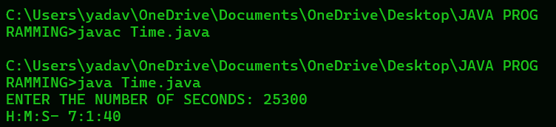**OUTPUT:**

**Question 2 -> Write a java program to convert a given integer(in days) to years, months and day,s assumes that all months have 30 days and all years have 365 days.**

**// SOURCE CODE**

import java.util.Scanner;

class Days {

public static void main(String args [ ] ) {

**//declare a variable**

int Y,M,D,Totaldays,Remainingdays;

Scanner sc = new Scanner(System.in);

System.out.println("ENTER NUMBER OF DAYS: " );

Totaldays = sc.nextInt();

**// perform the operation**

Y = Totaldays / 365;

Remainingdays = Totaldays % 365;

M = Remainingdays/30;

D = Remainingdays % 30;

System.out.println("YEARS: " + Y);

System.out.println("MONTHS: " + M);

System.out.println("DAYS: " + D);

}

}

**OUTPUT:**

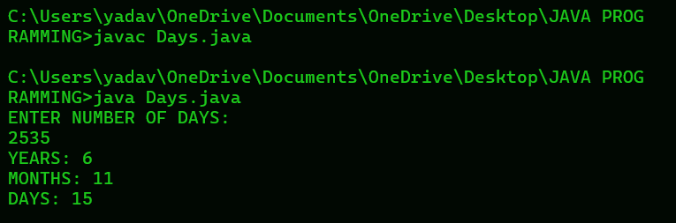

**Question 3 -> Write a java programme that read 5 numbers and sum of all odd values between them**

**//SOURCE CODE**

import java.util.Scanner;

class SumOdd{

public static void main(String args[ ] ) {

**//declare a variable**

int number,sum=0;

Scanner sc = new Scanner(System.in);

for ( int i = 0 ; i < 5; i++){

System.out.print("ENTER A NUMBER: ");

number = sc.nextInt();

**//perform the operation**

if( number % 2 != 0){

**// Addition assignment operator**

**// sum = sum + number**

sum += number;

}

}

System.out.println("THE SUM OF ODD VALUES: " + sum);

}

}

**OUTPUT :**

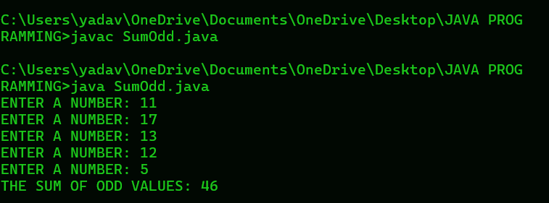

**Question 4 - > Write a java programme that reads two integer and checks whether they are multiplied or not .**

**// SOURCE CODE**

import java.util.Scanner;

class Multiplied {

public static void main(String args[ ] ){

**// declare a variable**

int a , b;

Scanner sc = new Scanner(System.in);

System.out.print("ENTER A FIRST NUMBER: " );

a = sc.nextInt();

System.out.print("ENTER A SECOND NUMBER: ");

b = sc.nextInt();

**// perform the operation**

if ( a / b == 0 ) {

System.out.println("Multiplied");

}

else{

System.out.println("Not");

}

}

}

**OUTPUT :**

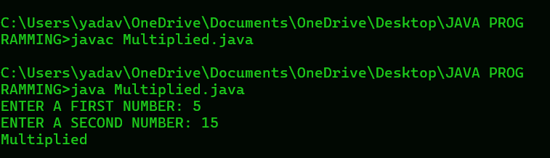

**Question 5 - > Write a java programme that reads an integer between 1 and 12 and print the month of the year in English.**

**// BY USING SWITCH CASE**

**// SOURCE CODE**

import java.util.Scanner ;

class Months{

public static void main(String args[ ] ) {

**// delcare a variable**

String month;

int monthnumber;

Scanner sc = new Scanner(System.in);

System.out.print("INPUT A NUMBER BETWEEN 1 TO 12 AND GET THE MONTH NAME: ");

monthnumber = sc.nextInt();

switch(monthnumber){

case 1:

month = " January ";

break;

case 2:

month = " February ";

break;

case 3:

month = " March ";

break;

case 4:

month = " April ";

break;

case 5:

month = " May ";

break;

case 6:

month = " June ";

break;

case 7:

month = " July ";

break;

case 8:

month = " August ";

break;

case 9:

month = " September ";

break;

case 10:

month = " October ";

break;

case 11:

month = " November ";

break;

case 12:

month = " December ";

break;

default:

month = " Invalid month number ";

}

System.out.println("MONTH: " + month);

}

}

**OUTPUT:**

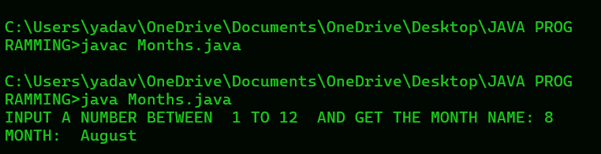

**Question 6 -> Write a java programme that read 5 numbers and counts the number of positive numbers and negative numbers**

**// SOURCE CODE**

import java.util.Scanner;

class CountNumber{

public static void main(String args [ ] ) {

**// declare a variable**

int N;

int positiveCount = 0;

int negativeCount = 0;

Scanner sc = new Scanner(System.in);

for(int i = 0 ; i < 5; i++){

System.out.print("ENTER A NUMBER: ");

N = sc.nextInt();

if ( N > 0 ) {

positiveCount++;

}

else {

negativeCount++;

}

}

System.out.println("Number of positive number : " + positiveCount);

System.out.println("Number of negative number: " + negativeCount);

}

}

**OUTPUT :**

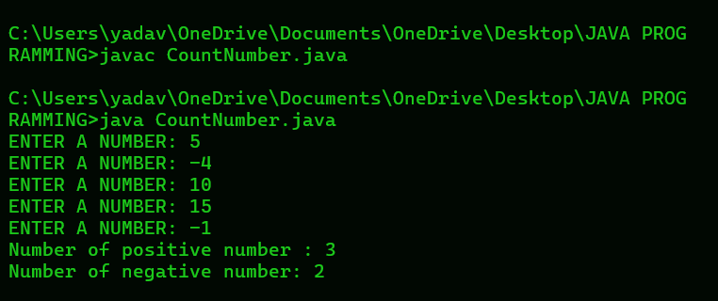

**Question 7 -> Write a java program that read 5 numbers and counts the number of positive number and print the average of all positive values.**

**// SOURCE CODE**

import java.util.Scanner;

class AverageNumber{

public static void main(String args [ ] ) {

**// declare a variable**

int N;

int positiveCount = 0;

int sum = 0;

double average;

Scanner sc = new Scanner(System.in);

for(int i = 0 ; i < 5; i++){

System.out.print("ENTER A NUMBER: ");

N = sc.nextInt();

if ( N > 0 ) {

sum += N;

positiveCount++;

}

}

average = sum / positiveCount;

System.out.println("Number of positive number : " + positiveCount);

System.out.println("Average value of the said positive number : " + average);

}

}

**OUTPUT:**

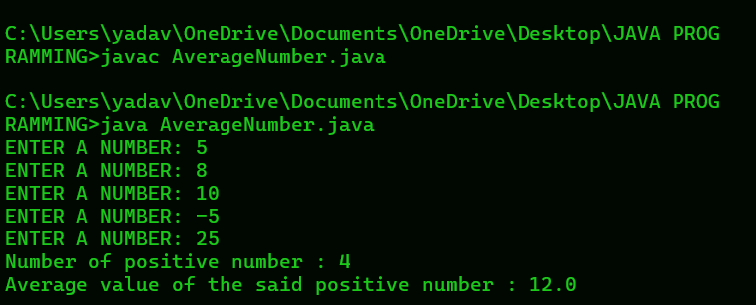

**Question 8 -> Write a java programme that read 5 numbers and sum of all odd values between them**

**//SOURCE CODE**

import java.util.Scanner;

class SumOdd{

public static void main(String args[ ] ) {

**//declare a variable**

int number,sum=0;

Scanner sc = new Scanner(System.in);

for ( int i = 0 ; i < 5; i++){

System.out.print("ENTER A NUMBER: ");

number = sc.nextInt();

**//perform the operation**

if( number % 2 != 0){

**// Addition assignment operator**

**// sum = sum + number**

sum += number;

}

}

System.out.println("THE SUM OF ODD VALUES: " + sum);

}

}

**OUTPUT :**

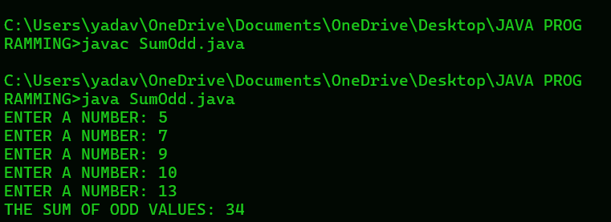

**Question 9 -> Write a java programme that converts Centigrade to Fahrenheit.**

**// SOURCE CODE**

import java.util.Scanner;

class ConvertCentigrade{

public static void main(String args[ ] ) {

**// declare variable**

int C;

float F;

Scanner sc = new Scanner(System.in);

System.out.print("ENTER A CENTIGRADE: ");

C = sc.nextInt();

F = ( C * 9.0f / 5 ) + 32;

System.out.println("Fahrenheit : " + F);

}

}

**OUTPUT :**

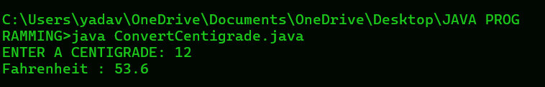

**Question 10 - > Write a java programme that converts kilometers per hour to miles per hour.**

**// SOURCE CODE**

import java.util.Scanner ;

class ConvertKilo {

public static void main(String args [ ] ) {

**// declare a variable**

int K;

float Onekm = 0.6213712f , Mile;

Scanner sc = new Scanner(System.in);

System.out.print("ENTER A KILOMETER PER HOUR: " ) ;

K = sc.nextInt();

Mile = Onekm * K;

System.out.println(Mile + " miles per hour");

}

}

**OUTPUT :**

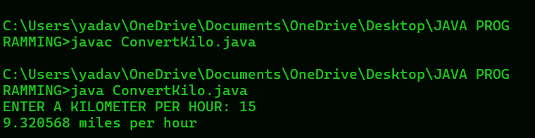

**Question 11 - > Write a java programme to check two given integers , and print true if one of them is 30 or if their sum is 30 else print false.**

**// SOURCE CODE**

import java.util.Scanner;

class CheckThirty{

public static void main(String args [ ] ) {

**// declare a variable**

int a , b;

boolean result;

Scanner sc = new Scanner(System.in);

System.out.print("ENTER A FIRST VALUE: ");

a = sc.nextInt();

System.out.print("ENTER A SECOND VALUE: ");

b = sc.nextInt();

result = ( a == 30 || b == 30 || a + b == 30);

System.out.println(result);

}

}

**OUTPUT :**

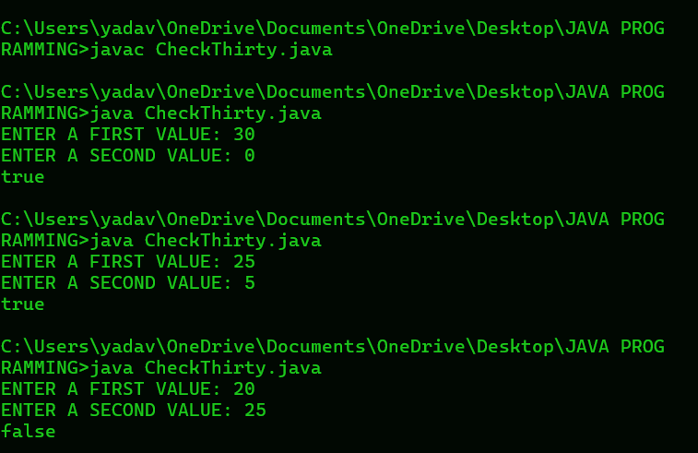

**Question 12 - > Write a java programe that takes hours and minutes as input, and calculate the total number of minutes**

// **SOURCE CODE**

import java.util.Scanner;

class TotalMinutes{

public static void main(String args [ ] ) {

**// declare a variable**

int H , M , Total;

Scanner sc = new Scanner(System.in);s

System.out.print("ENTER A HOURS : ");

H = sc.nextInt();

System.out.print("ENTER A MINUTES: ");

M = sc.nextInt();

Total = (H * 60 ) + M; // 1 hour = 60 minutes

System.out.println("TOTAL NUMBER OF MINUTES: " + Total);

}

}

**OUTPUT :**

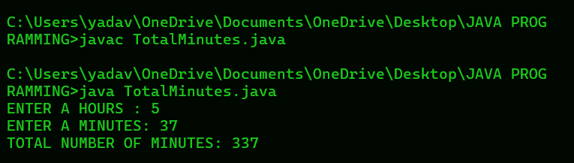

**Question 13 - > Write a java programme to integral quotient and remainder of a division**

**// SOURCE CODE**

import java.util.Scanner;

class IntegralDivision{

public static void main(String args [ ] ) {

**// declare a variable;**

int N , D , Q , R;

Scanner sc = new Scanner(System.in);

System.out.print("ENTER A NUMERATOR: " ) ;

N = sc.nextInt();

System.out.print("ENTER A DENOMINATOR: ");

D = sc.nextInt();

Q = N / D;

R = N % D;

System.out.println("Quotient: " + Q );

System.out.println("Remainder: " + R);

}

}

**OUTPUT :**

